**8th Grade Math Summer Packet**

Name________________________________

Hello students! This is a take home summer packet that covers many important skills that will be necessary to enter Algebra next year. I would *highly* recommend selecting lessons from the 8th grade math Khan Academy course (link here: <https://www.khanacademy.org/math/cc-eighth-grade-math>.) You can also find this link on the math/Algebra resources page of my website Next to each problem I also put some key search phrases that will help you search Khan Academy or the web for tutorials. You may also email me over the summer if you are having problems finding resources.

In order to enter Algebra you will need to finish this packet with all of your work shown, and in the Fall you will need to get a 75% or better on a test that will have very similar problems to the problems in this packet. Good Luck and let me know if you have any questions.

1. Simplify each expression with or without algebra tiles. Record your steps. **(Combining like terms)**

1. 3 + 7*x* − (2 + 9*x*)
2. 6 − (3*x* − 4) + 7*x* – 11
3. 3*x*2 + 10 − *y*2 + 4*x* − 8*x*2 − 5y − 8 +*y*2 + 3

d. Evaluate the following expression 3 + 7x − (2 + 9x) **(Evaluating algebraic expressions)**

When:

x = 2

x = -2

2. Molly bought 4.25 pounds of fish for $13. **(unit rates)**

1. What is the unit rate (cost per pound)?
2. What should six pounds of fish cost at the same rate?

3. Solve each equation and check your solution. **(Solving linear equations and the distributive property)**

a. 3(2 + x) = 4 − (x − 2) b. 

c. 3(2x − 1) + 7 = −44 d. 6(2x − 5) = −(x + 4)

e. 13 − 4x = 1 – x f. 10) −10 + x + 4 − 5 = 7x – 5

4. What is the equation for the line below: **(Writing linear equations from lines, slope and y intercept of equations)**

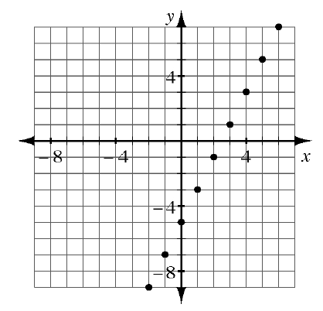

Find the slope of the line below:

What is the slope and y intercept of this line: y=1/2x -3

Write an equation for a line with a slope of 3 and a y intercept of -1

5. For each pair of lines below, solve the system first by graphing and then algebraically using the Equal Values Method.  Explain how the graph confirms the algebraic result. **(solving systems of equations with the equal values method and by graphing)**

1. *y* = 7*x* − 5 and *y* = −2*x* + 13

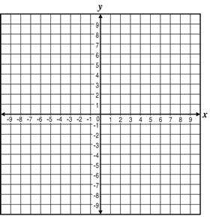

1. *y* = 3*x* − 1 and *y* = 3*x* + 2



6. Graph the following lines on the graph below. Clearly label your line. **(graphing linear equations)**

a. y = 3x +2

b. y = -2x +4

c. y = -x - 2

d. y = 3x



7. Show the locations of the following numbers on the number line below. **(Square roots)**

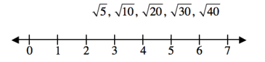

8. Neatly graph the points (−2, 9), (−3, 7) and (−5, 10) on a four-quadrant graph.  Connect them to make a triangle.  Then, for each transformation described below: **(transformations on a coordinate plane)**



1. Describe what happens to the coordinates when you slide the triangle right 4 units and down 6 units. Show on the graph.
2. Describe what happens to the coordinates when you reflect the triangle across the *y‑*axis. Show on the graph.

9. Daniel has $1200 in the bank.  He is earning 3.5% simple interest each month. **(simple interest formula)**

a. How much money will he have in the bank in one year?

b. Would Daniel have more money if the interest was compounded? How do you know?

13. The triangles below are similar. **(Finding sides of similar triangles)**

* 1. Find  *x*.
  2. Find  *y*.

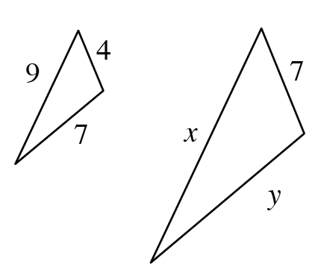

14. Complete the following table **(scientific notation)**

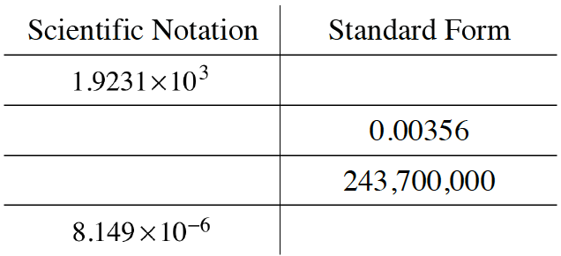

15. Solve for  x. **(Internal and external angles of triangles, angles of parallel lines cut by a transversal)**

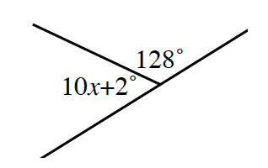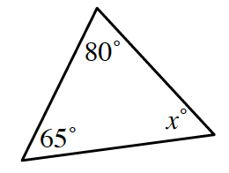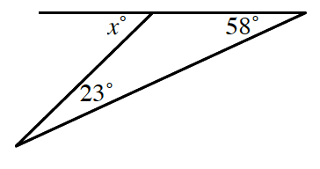

128º

52º

5*x* + 3º

16. Simplify the following exponential expressions.  Give answers without negative exponents. **(Exponent rules)**

1. 4−3 · 47 b. (5*x*4)3
2. 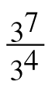 d. (4*x*5)(3*x*−8)

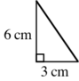17.)         Find the perimeter of the figure **(Pythagorean Theorem)**

18. Find the surface area and volume of the cylinder below.  Show your work clearly. **(Surface area and volume of a cylinder)**

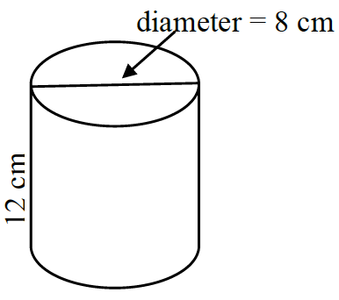

20.) Simplify each of the following expressions. **(Order of operations)**

a. (12 + 48) × 2 ÷ (13 + 7) – 25

b. (62 + 23) ÷ (2 × 5) – 8 + 32

c. 53 ÷ 5 + 6 × (87 – 82)

d. 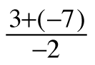

e. 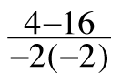

21.) Simplify **(fraction operations)**

a.  b.  c. 

d. e. f. 5https://ebooks.cpm.org/images/shared/1-2.gif · 1pic

g.  h.  i. 

22.) Find the value of each expression without using a calculator. **(Integer operations)**

a.        –3 + 12         b.        –6 – (–12)         c.        –10 + (–7)

d.        7 – (–10)       e.        4 – 10               f.        –12 – 2

g.        –6(–8)           h.        12(–5)              i.        –17 + 6